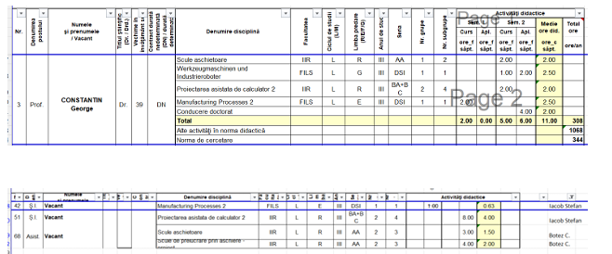

Laborator:

Post 51 (PO)

Conf. dr. ing. Stefan IACOB

